**Chapter 6**

**Vector Calculus**

**6.8 The Divergence Theorem**

**Section Exercises**

**For the following exercises, use a computer algebraic system (CAS) and the divergence theorem to evaluate surface integral  for the given choice of F and the boundary surface *S.* For each closed surface, assume N is the outward unit normal vector.**

377. **[T]** *S* is the surface of hemisphere  together with disk  in the *xy*-plane.

Answer: 

379. **[T]** *S* is the surface of paraboloid 

Answer: 

381. **[T]** *S* is the surface of the solid bounded by cylinder  and planes 

Answer: 

383. **[T]** *S* is the surface bounded by cylinder  and planes 

Answer: 

385. Use the divergence theorem to calculate surface integral  where  and *S*is upper hemisphere  oriented upward.

Answer: 

387. Use the divergence theorem to calculate surface integral  when  and *S* is the surface of the box with vertices 

Answer: 

389. **[T]** Use a CAS and the divergence theorem to calculate flux , where  and *S* is a sphere with center (0, 0) and radius 2.

Answer: 

391. Use the divergence theorem to compute flux integral where and *S* consists of the union of paraboloid and disk  oriented outward. What is the flux through just the paraboloid?

Answer: 

393. Use the divergence theorem to calculate surface integral  for  where *S* is the surface bounded by cylinder  and planes 

Answer: 

**For the following exercises, use a CAS along with the divergence theorem to compute the net outward flux for the fields across the given surfaces *S*.**

395. **[T]**  *S* is sphere 

Answer: 

397. **[T]**  *S* is sphere 

Answer: 

**For the following exercises, use a CAS and the divergence theorem to compute the net outward flux for the vector fields across the boundary of the given regions *D*.**

399. **[T]** *D* is the region between spheres of radius 2 and 4 centered at the origin.

Answer: 

401. **[T]** *D* is the region in the first octant between planes  and 

Answer: 20

403. Use the divergence theorem to find the outward flux of field  through the cube bounded by planes 

Answer: 

405. Evaluate  where  and *S* is the surface consisting of all faces except the tetrahedron bounded by plane  and the coordinate planes, with outward unit normal vector **N**.

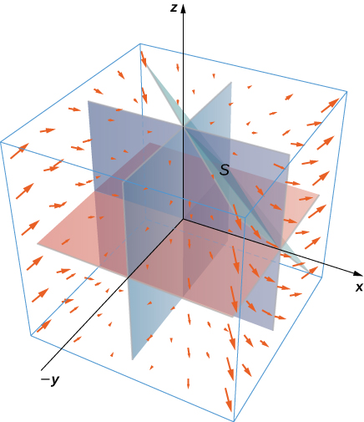

Answer: 

407. Use the divergence theorem to evaluate , where  and *S* is sphere  with constant 

Answer: 

409. Let *R* be the region defined by  Use the divergence theorem to find 

Answer: 

411. Let *E* be the solid unit cube with diagonally opposite corners at the origin and (1, 1, 1), and faces parallel to the coordinate planes. Let *S* be the surface of *E*,oriented with the outward-pointing normal. Use a CAS to find  using the divergence theorem if .

Answer: 

413. Find  where and *S* is the outwardly oriented surface obtained by removing cube  from cube 

Answer: 

415. Compute the flux of water through parabolic cylinder  from , if the velocity vector is .

Answer: 

417. **[T]** Use a CAS to find the flux of vector field  through surface *S*, where *S* is given by  from  oriented so the unit normal vector points downward.

Answer: 

419. Evaluate , where  and *S* is a closed surface bounding the region andconsisting of solid cylinder  and 

Answer: 

421. Use the divergence theorem to evaluate , where  and *S* is the surface consisting of three pieces:  on the top;  on the sides; and  on the bottom.

Answer: 

423. Use the divergence theorem to evaluate , where  and *S* is the boundary of the solid enclosed by paraboloid  cylinder  and plane  and *S* is oriented outward.

Answer: 

**For the following exercises, Fourier’s law of heat transfer states that the heat flow vector F at a point is proportional to the negative gradient of the temperature; that is,  which means that heat energy flows hot regions to cold regions. The constant  is called the *conductivity*, which has metric units of joules per meter per second-kelvin or watts per meter-kelvin. A temperature function for region *D* is given. Use the divergence theorem to find net outward heat flux  across the boundary *S* of *D*, where ** .

425.  

Answer: 

**Chapter Review Exercises**

***True or False.* Justify your answer with a proof or a counterexample.**

427. Vector field  is conservative.

Answer: False

429. The divergence of a vector field is a vector field.

Answer: False

**Draw the following vector fields.**

431. 

Answer:

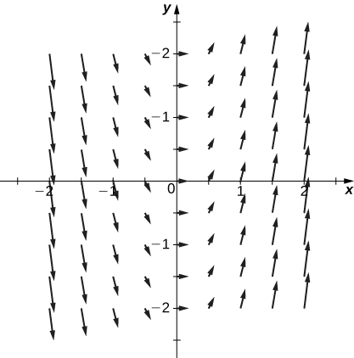

**Are the following the vector fields conservative? If so, find the potential function *f* such that **

433. 

Answer: Conservative, 

435. 

Answer: Conservative, 

**Evaluate the following integrals.**

437.  along  from (0, 0) to (4, 2)

Answer: 

439.  where *S* is surface 

Answer: 

**Find the divergence and curl for the following vector fields.**

441. 

Answer: Divergence:  curl: 

**Use Green’s theorem to evaluate the following integrals.**

443.  where *C* is a circle centered at the origin with radius 3

Answer: 

**Use Stokes’ theorem to evaluate .**

445. , whereis the upward-facing paraboloid  lying in cylinder 

Answer: 

**Use the divergence theorem to evaluate .**

447. , where  is bounded by paraboloid and plane

Answer: 

449. Find the total mass of a thin wire in the shape of a semicircle with radius  and a density function of 

Answer: 

451. Use the divergence theorem to compute the value of the flux integral over the unit sphere with .

Answer: 

This file is copyright 2016, Rice University. All Rights Reserved.